**ASSIGNMENT**

**CLOUD COMPUTING**

**NAME : ARSHIYA SRIVASTAVA**

**ROLL NO : 22/1404**

**MSc Informatics, Semester 3**

1. Screenshot of **timestamp** and **system user name** with **MySQL workbench** open.

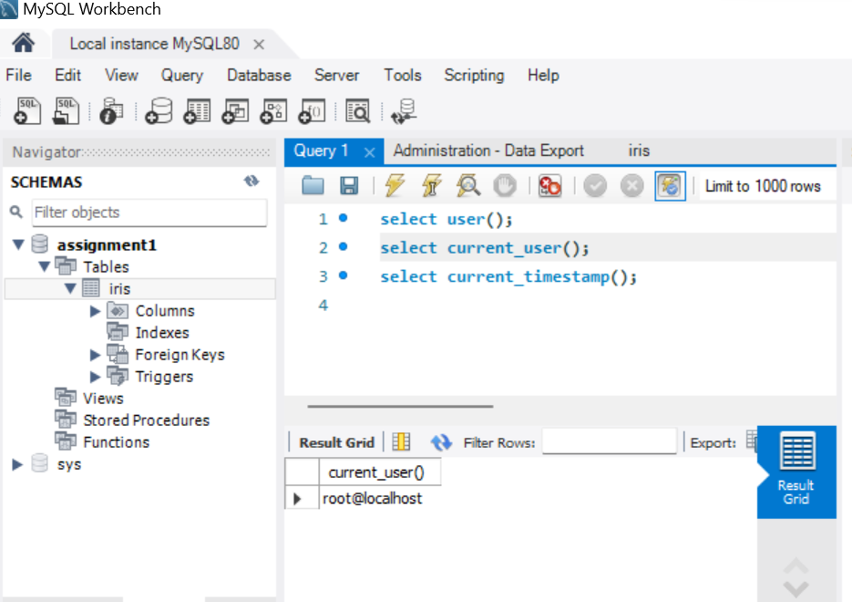

2. Screenshot of **MySQL** **running** on **terminal** or **command** **prompt**.

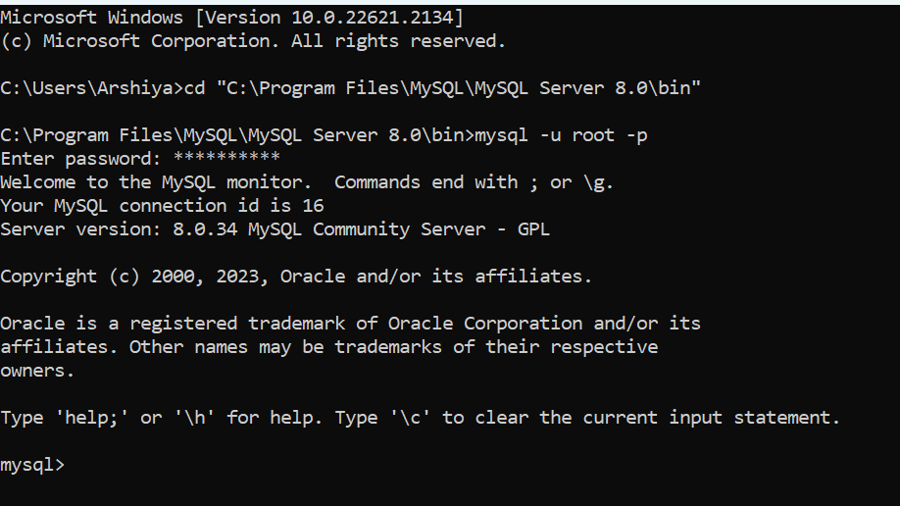

3. Screenshot of the **top 10** objects **retrieved** from the **table** using **SELECT** query.

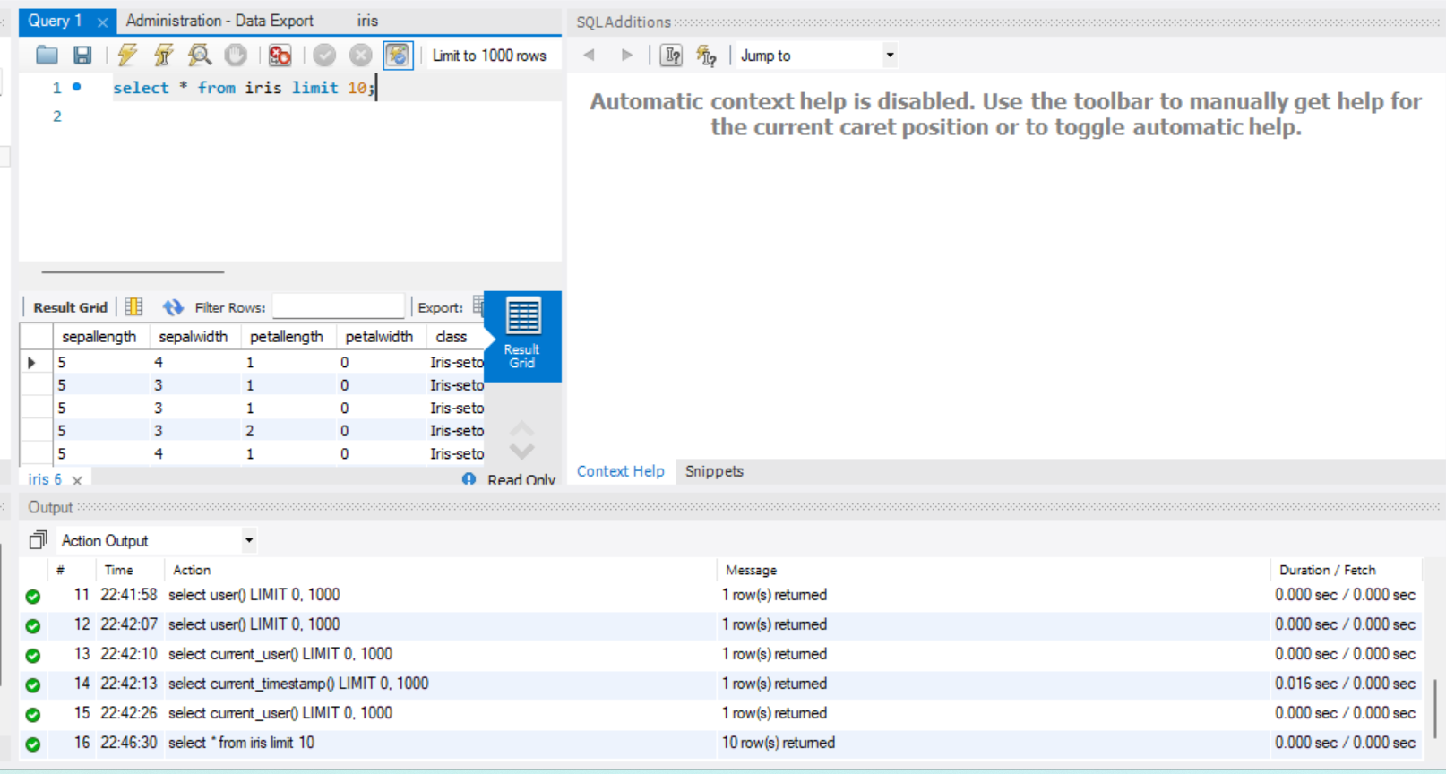

Q1. Can you store these data objects in a **MySQL table** along with a **primary key** (**INT** type) **ID column** and a **DESCRIPTION** column (**TEXT** type)?

In MySQL, we can store large data objects like text, binary data, or files using columns with data types such as TEXT, BLOB, LONGTEXT, LONGBLOB, etc. ID Column can be made a primary key of INT type and the DESCRIPTION Column can be made of type TEXT.

Q2. According to you, what can be an ideal solution for storing the information of such objects in a table?

Storing large objects, such as files or binary data, in a relational database table is generally not the ideal solution due to performance and scalability concerns. We can store the actual large objects (files or binary data) in a file system or cloud storage. Each object should have a unique identifier that corresponds to the ID in the database table. Organize the files in a structured way on our file system or we can use a cloud storage service like Amazon S3, Azure Blob Storage, or Google Cloud Storage.